Aggregation:
Create a dataframe with retail data,
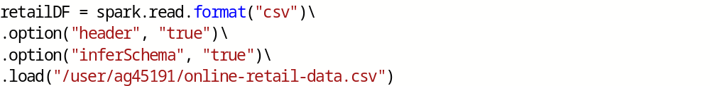
count & countDistinct:
To get the count of records and count of distinct records respectively.
Example:
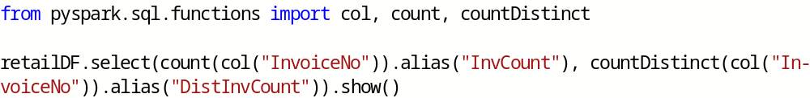
first & last:
To get first and last record values from a dataframe.
Example:
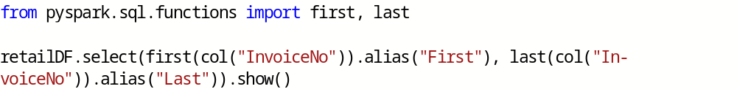
min & max:
To get min and max values.
Example:
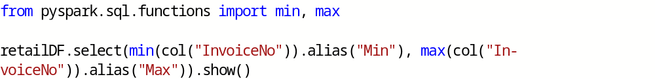
sum & sumDistinct:
To get sum and distinct sum of column values.
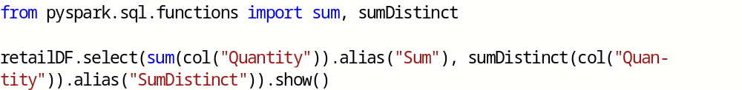
avg:
To get average of column values.
collect_set & collect_list:
In Spark, you can also perform aggregations on complex types.
collect_set - Collects the distinct values presented in a column.
collect_list - Collects all values presented in a column.
Example:
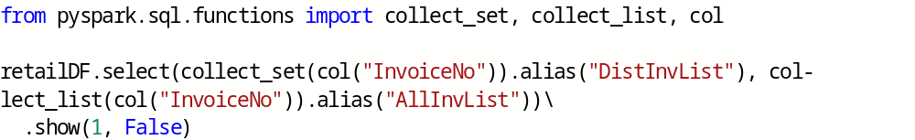

Grouping:
groupBy():
Like in SQL, we can also perform calculations based on groups in the data.
Example:
Grouping with Expressions:
Example:
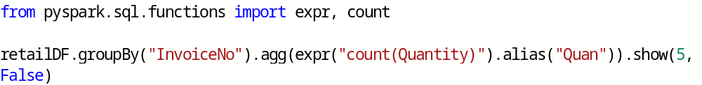
Window Functions:
Spark supports three kinds of window functions:
ranking functions, analytic functions, and aggregate functions.

The first step to a window function is to create a window specification.
partitionBy() - Used to split the rows into groups(a.k.a. partitions)
orderBy() - Used to sort the rows within the partition
rowsBetween() - Used to set the boundaries

Example:
Convert invoice date to simple date.
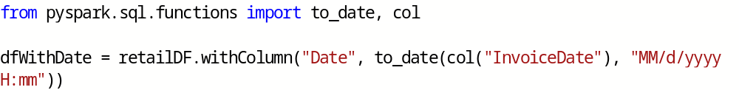
Create window specification,
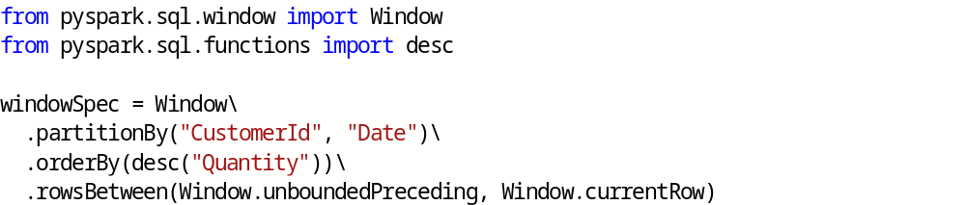
Window function to get max quantity of each customer,
Window function to get purchase quantity rank,
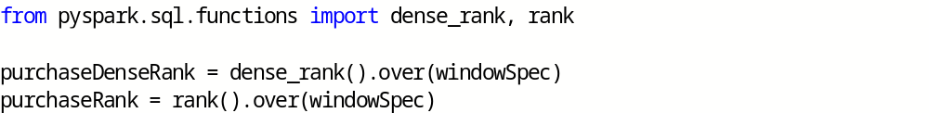
Now use above window functions in select statement,
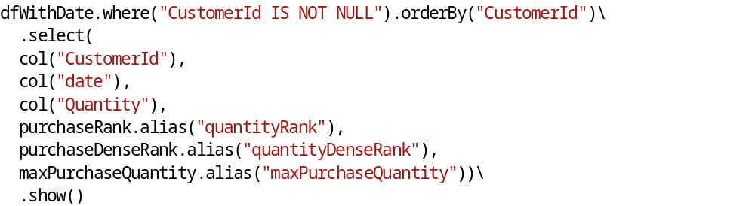
Rollup:
A rollup groups hierarchically from left to right.
The rolup option allows you to include extra rows that represent the subtotals along with the grand total row.
Example:
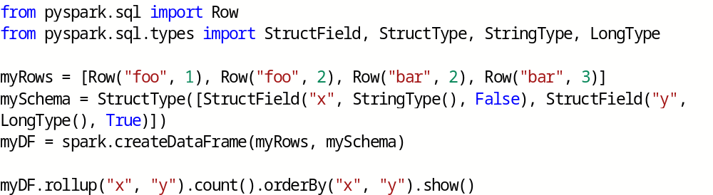
Cube:
Similar to rollup, but groups in all dimensions.
Example:
Grouping Metadata:
By using grouping_id(), you will able to see the aggregation level after applying rollup/cube functions.
Example:
Pivot:
This function converts a row into a column.
Example:
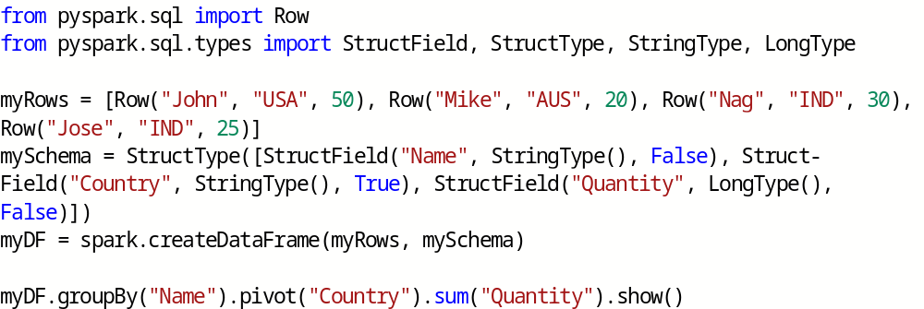

Joins:
Join Types:
- Inner joins (keep rows with keys that exist in the left and right datasets)
- Outer joins (keep rows with keys in either the left or right datasets)
- Left outer joins (keep rows with keys in the left dataset)
- Right outer joins (keep rows with keys in the right dataset)
- Left semi joins (keep the rows in the left, and only the left, dataset where the key appears in the right dataset)
- Left anti joins (keep the rows in the left, and only the left, dataset where they do not appear in the right dataset)
- Natural joins (perform a join by implicitly matching the columns between the two datasets with the same names)
- Cross (or Cartesian) joins (match every row in the left dataset with every row in the right dataset)
Join Syntax:
df1.join(df2, <joinExpression>, <joinType>)

Create two dataframes for demo,
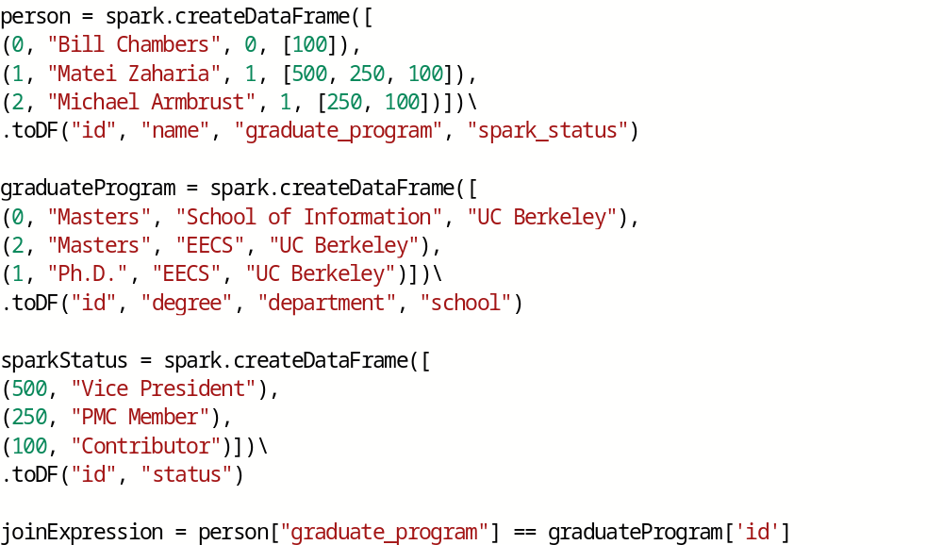

Inner Joins:
Inner joins evaluate the keys in both of the DataFrames or tables and include (and join together) only the rows that evaluate to true.
Ineer join is the default join.
Example:
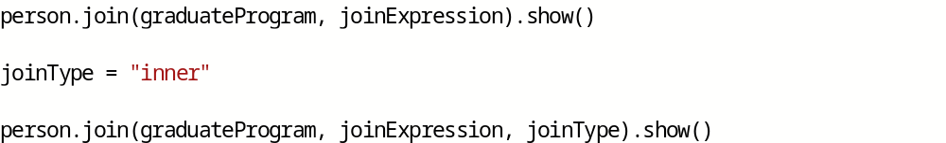
Outer Joins:
Outer joins evaluate the keys in both of the DataFrames or tables and includes (and joins together) the rows that evaluate to true or false.
If there is no equivalent row in either the left or right DataFrame, Spark will insert null.
Example:
Left Outer Joins:
Left outer joins evaluate the keys in both of the DataFrames or tables and includes all rows from the left DataFrame as well as any rows in the right DataFrame that have a match in the left DataFrame.
If there is no equivalent row in the right DataFrame, Spark will insert null.
Example:
Right Outer Joins:
Right outer joins evaluate the keys in both of the DataFrames or tables and includes all rows from the right DataFrame as well as any rows in the left DataFrame that have a match in the right DataFrame.
If there is no equivalent row in the left DataFrame, Spark will insert null.
Example:

Left Semi Joins:
Semi joins are a bit of a departure from the other joins. They do not actually include any values from the right DataFrame. They only compare values to see if the value exists in the second DataFrame.
If the value does exist, those rows will be kept in the result, even if there are duplicate keys in the left DataFrame.
Example:

Left Anti Joins:
Left anti joins are the opposite of left semi joins.
Like left semi joins, they do not actually include any values from the right DataFrame. They only compare values to see if the value exists in the second DataFrame.
However, rather than keeping the values that exist in the second DataFrame, they keep only the values that do not have a corresponding key in the second DataFrame.
Example:

Cross (Cartesian) Joins:
Cross joins will join every single row in the left DataFrame to ever single row in the right DataFrame.
This will cause an absolute explosion in the number of rows contained in the resulting DataFrame.
For this reason, you must very explicitly state that you want a cross-join by using the cross join keyword.
Example:
If you truly intend to have a cross-join, you can call that out explicitly:
Example:

